
NATIONAL UNIVERSITY OF TECHNOLOGY (NUTECH)

Course: CS160 - Database Systems
Instructor: Ms. Saima Yasmeen
Deadline: 15-06-2026
Batch: CS25-C
Semester: 2
Muhammad Arslan (f25605345)
Abdul Basit Afghanistani (f25605310)
Khizar Hayyat(f25605317)
Akber Ali(f25605344)
PROJECT-BASED LEARNING (PBL) REPORT

Task 1
1. System Architecture Overview

1.1 Project Description
The Library Management System (LMS) is a relational database solution designed to manage the core operational workflows of a public or institutional library. It handles member registration, book cataloguing, borrowing transactions, return tracking, fine calculation, and staff administration.
The database captures all business entities involved in day-to-day library operations, enforces strict referential integrity, and provides analytical querying capability via advanced SQL constructs.

1.2 Business Rules
- Each member has a unique library card number and may borrow up to 5 books at a time.
- Each book may have multiple copies; each copy is tracked individually.
- A transaction records which member borrowed which copy, the borrow date, and the due date.
- Fines are calculated at Rs. 10 per day for overdue returns.
- Staff members are categorized as Librarian, Assistant, or Admin.
- A book belongs to exactly one category, but a category can contain many books.
- Authors are tracked separately to support co-authorship (many-to-many with books).
- Reservations allow members to reserve unavailable books.

1.3 Entities Identified
Entity | Description
Member | Library card holders who borrow books
Staff | Library employees managing operations (supertype)
Librarian | Specialization of Staff – manages book cataloguing
Assistant | Specialization of Staff – handles desk operations
Admin | Specialization of Staff – manages system administration
Book | Bibliographic record of a title
BookCopy | Physical copy of a book (weak entity of Book)
Author | Person who authored a book (many-to-many with Book)
Category | Genre or classification of books
BorrowTransaction | Record of a borrowing event (associative entity)
Fine | Overdue penalty record linked to a transaction
Reservation | A member's request to hold a book title

Enhanced Entity-Relationship Diagram (EERD)

EERD Description
The EERD below captures all entity sets, their attributes (including composite and multi-valued), primary/foreign keys, relationship cardinalities, participation constraints, weak entities, associative entities, and a Generalization/Specialization hierarchy for Staff.
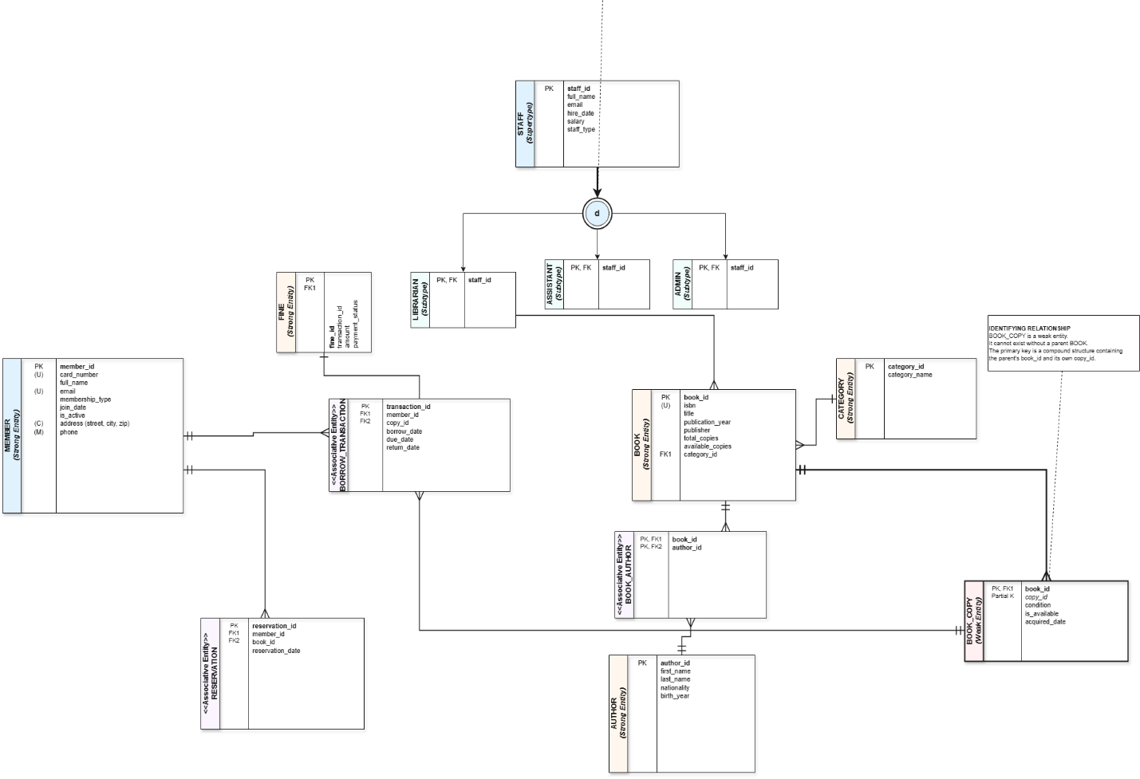

Task 2: Enhanced Entity-Relationship Diagram (EERD)

2.1 EERD Description
The EERD captures all entity sets with their attributes including composite and multi-valued ones, primary/foreign keys, relationship cardinalities, participation constraints, weak entities, associative entities, and a Generalization/Specialization hierarchy for Staff.

2.2 Entities, Attributes & Relationships
Member
The Member entity represents library card holders who can borrow books. Key attributes are listed below:
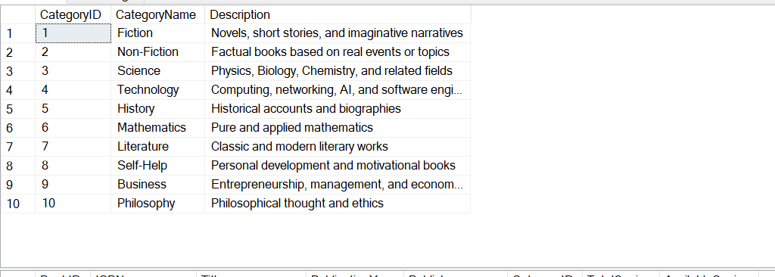
Phone is a multi-valued attribute stored in a separate MemberPhone table. Address is a composite attribute broken into Street, City, and ZipCode columns for normalization.

Book
The Book entity holds bibliographic records for each title available in the library.

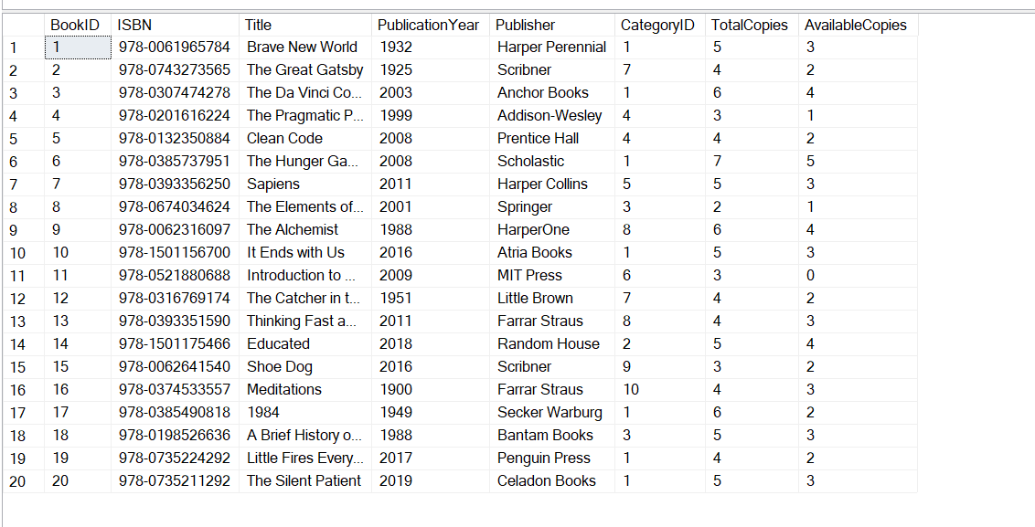
Each Book belongs to exactly one Category (total participation on Book side). TotalCopies and AvailableCopies are maintained separately to track physical inventory.

BookCopy (Weak Entity - depends on Book)
BookCopy is a weak entity that represents each individual physical copy of a book. It cannot exist without its owner entity Book.
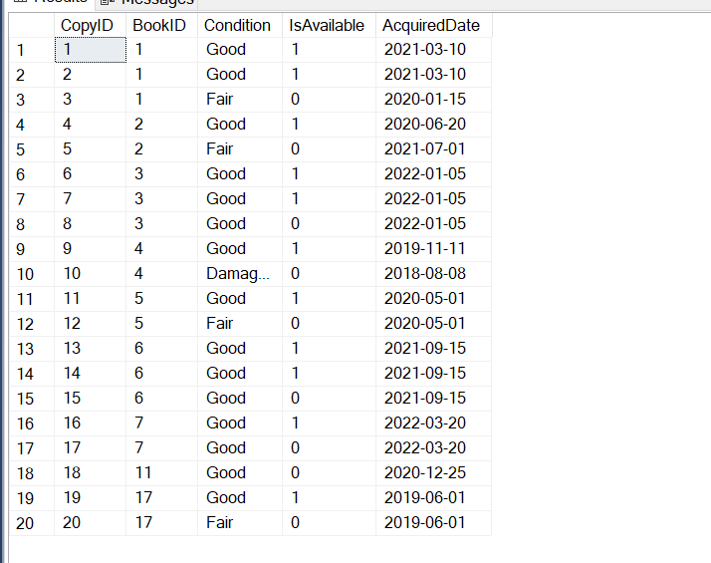
The CASCADE delete rule ensures that when a Book is removed, all its associated copies are also deleted automatically, maintaining referential integrity for the weak entity relationship.

Author (Many-to-Many with Book via BookAuthor)
Authors are tracked separately to support co-authorship scenarios, forming a many-to-many relationship with books through the associative BookAuthor table.
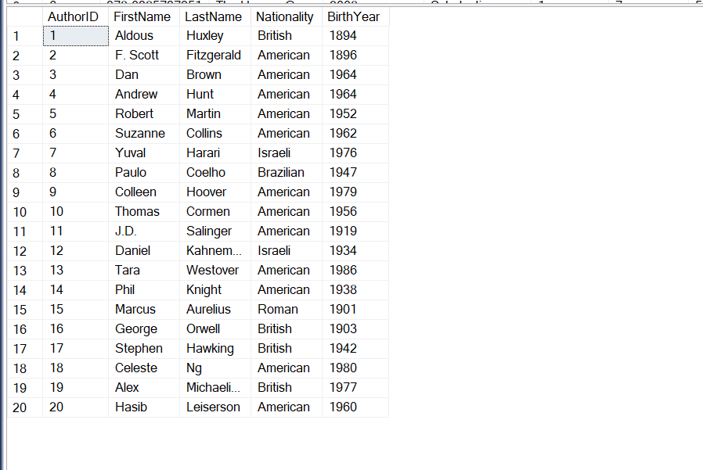

Nationality and BirthYear are optional (NULL allowed) since these may not always be known for all authors.

Staff (Supertype) - Generalization/Specialization
Staff is the supertype in a generalization/specialization hierarchy. The single-table inheritance strategy is used with a StaffType discriminator column. Subtypes Librarian, Assistant, and Admin each have their own table for subtype-specific attributes.
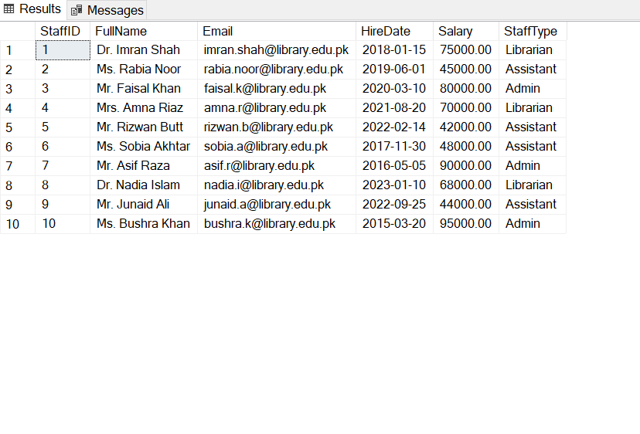
Librarian
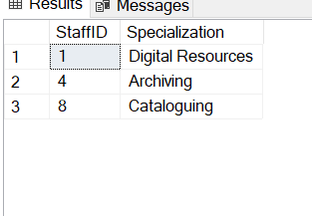
Assistant
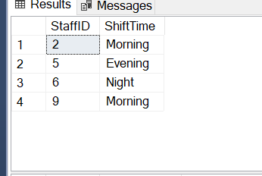
Admin
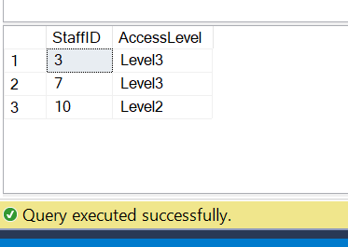

The StaffType column acts as a discriminator for the supertype/subtype hierarchy. Each staff member is stored once in the Staff table, and subtype-specific attributes are in their respective subtype tables (Librarian, Assistant, Admin).

Relationship Summary
The following relationships exist among the entities in the Library Management System:

Total participation means every instance of that entity must participate in the relationship. Partial participation means participation is optional. The M:N relationships (Borrows, Reserves, Written By) are resolved through associative/junction tables.

Task 3: Relational Schema Mapping & DDL Implementation

3.1 Schema Mapping Summary
All EERD entities and relationships have been mapped to physical SQL tables. Weak entities use CASCADE on their owner foreign key. The Staff supertype uses single-table inheritance with a StaffType discriminator column, and each subtype table holds its unique attributes.

3.2 DDL - CREATE TABLE Scripts
Category Table
CREATE DATABASE IF NOT EXISTS LibraryDB;
USE LibraryDB;

-- Table: Category
CREATE TABLE Category (
CategoryID INT AUTO_INCREMENT PRIMARY KEY,
CategoryName VARCHAR(80) NOT NULL UNIQUE,
Description VARCHAR(255) NULL
);

The Category table stores book genres and classifications. CategoryName is unique to prevent duplicate categories. Description is optional (NULL allowed).

Book Table
-- Table: Book
CREATE TABLE Book (
BookID INT AUTO_INCREMENT PRIMARY KEY,
ISBN VARCHAR(20) NOT NULL UNIQUE,
Title VARCHAR(200) NOT NULL,
PublicationYear YEAR NOT NULL,
Publisher VARCHAR(100) NOT NULL,
CategoryID INT NOT NULL,
TotalCopies INT NOT NULL DEFAULT 0 CHECK (TotalCopies >= 0),
AvailableCopies INT NOT NULL DEFAULT 0 CHECK (AvailableCopies >= 0),
CONSTRAINT fk_book_category FOREIGN KEY (CategoryID)
REFERENCES Category(CategoryID) ON DELETE RESTRICT ON UPDATE CASCADE
);

ON DELETE RESTRICT prevents deletion of a category that still has books assigned to it. ON UPDATE CASCADE propagates category ID changes automatically. CHECK constraints ensure copy counts never go negative.

BookCopy Table (Weak Entity)
-- Table: BookCopy (Weak Entity)
CREATE TABLE BookCopy (
CopyID INT AUTO_INCREMENT PRIMARY KEY,
BookID INT NOT NULL,
Condition ENUM('Good','Fair','Damaged') NOT NULL DEFAULT 'Good',
IsAvailable BOOLEAN NOT NULL DEFAULT TRUE,
AcquiredDate DATE NOT NULL,
CONSTRAINT fk_copy_book FOREIGN KEY (BookID)
REFERENCES Book(BookID) ON DELETE CASCADE ON UPDATE CASCADE
);

ON DELETE CASCADE implements the weak entity dependency - deleting a book automatically removes all its physical copies. The Condition ENUM restricts values to Good, Fair, or Damaged states only.

Author Table
-- Table: Author
CREATE TABLE Author (
AuthorID INT AUTO_INCREMENT PRIMARY KEY,
FirstName VARCHAR(50) NOT NULL,
LastName VARCHAR(50) NOT NULL,
Nationality VARCHAR(50) NULL,
BirthYear YEAR NULL
);

Author is maintained as a separate entity to enable the many-to-many co-authorship relationship. Nationality and BirthYear are nullable since this information is not always available.

BookAuthor Table (Associative - Many-to-Many)
-- Table: BookAuthor (Associative - Many-to-Many)
CREATE TABLE BookAuthor (
BookID INT NOT NULL,
AuthorID INT NOT NULL,
PRIMARY KEY (BookID, AuthorID),
CONSTRAINT fk_ba_book FOREIGN KEY (BookID)
REFERENCES Book(BookID) ON DELETE CASCADE,
CONSTRAINT fk_ba_author FOREIGN KEY (AuthorID)
REFERENCES Author(AuthorID) ON DELETE CASCADE
);

The composite primary key (BookID, AuthorID) prevents duplicate author-book assignments. Both foreign keys use CASCADE to clean up associations when either a book or author is deleted.

Member Table
-- Table: Member
CREATE TABLE Member (
MemberID INT AUTO_INCREMENT PRIMARY KEY,
CardNumber VARCHAR(20) NOT NULL UNIQUE,
FullName VARCHAR(100) NOT NULL,
Email VARCHAR(100) NOT NULL UNIQUE,
Street VARCHAR(100) NULL,
City VARCHAR(50) NULL,
ZipCode VARCHAR(10) NULL,
MembershipType ENUM('Standard','Premium') NOT NULL DEFAULT 'Standard',
JoinDate DATE NOT NULL,
IsActive BOOLEAN NOT NULL DEFAULT TRUE
);

The composite Address attribute from the EERD is flattened into Street, City, and ZipCode columns for first normal form compliance. CardNumber and Email are both unique identifiers for a member.

MemberPhone Table (Multi-Valued Attribute)
-- Table: MemberPhone (Multi-valued attribute of Member)
CREATE TABLE MemberPhone (
PhoneID INT AUTO_INCREMENT PRIMARY KEY,
MemberID INT NOT NULL,
Phone VARCHAR(15) NOT NULL,
CONSTRAINT fk_phone_member FOREIGN KEY (MemberID)
REFERENCES Member(MemberID) ON DELETE CASCADE
);

The multi-valued Phone attribute from the EERD is resolved into a separate table. This allows each member to have multiple phone numbers. CASCADE delete removes all phone records when a member is deleted.

Staff Table (Supertype)
-- Table: Staff (Supertype with StaffType discriminator)
CREATE TABLE Staff (
StaffID INT AUTO_INCREMENT PRIMARY KEY,
FullName VARCHAR(100) NOT NULL,
Email VARCHAR(100) NOT NULL UNIQUE,
HireDate DATE NOT NULL,
Salary DECIMAL(10,2) NOT NULL CHECK (Salary > 0),
StaffType ENUM('Librarian','Assistant','Admin') NOT NULL
);

Single-table inheritance stores all staff common attributes here. The StaffType ENUM discriminator determines which subtype table holds the additional attributes. CHECK constraint on Salary ensures no zero or negative salary is entered.

Librarian Table (Subtype)
-- Table: Librarian (Subtype)
CREATE TABLE Librarian (
StaffID INT PRIMARY KEY,
Specialization VARCHAR(80) NULL,
CONSTRAINT fk_librarian_staff FOREIGN KEY (StaffID)
REFERENCES Staff(StaffID) ON DELETE CASCADE
);

The Librarian subtype holds its specialization area such as Digital Resources or Archiving. The StaffID serves as both primary key and foreign key, implementing the subtype relationship.

Assistant Table (Subtype)
-- Table: Assistant (Subtype)
CREATE TABLE Assistant (
StaffID INT PRIMARY KEY,
ShiftTime ENUM('Morning','Evening','Night') NOT NULL,
CONSTRAINT fk_assistant_staff FOREIGN KEY (StaffID)
REFERENCES Staff(StaffID) ON DELETE CASCADE
);

The Assistant subtype stores the shift assignment. The ShiftTime ENUM restricts values to the three valid shift options: Morning, Evening, or Night.

Admin Table (Subtype)
-- Table: Admin (Subtype)
CREATE TABLE Admin (
StaffID INT PRIMARY KEY,
AccessLevel ENUM('Level1','Level2','Level3') NOT NULL DEFAULT 'Level1',
CONSTRAINT fk_admin_staff FOREIGN KEY (StaffID)
REFERENCES Staff(StaffID) ON DELETE CASCADE
);

Admin staff have tiered access levels (Level1 through Level3) controlling system permissions. Level3 grants the highest administrative privileges.

BorrowTransaction Table (Associative Entity)
-- Table: BorrowTransaction (Associative Entity)
CREATE TABLE BorrowTransaction (
TransactionID INT AUTO_INCREMENT PRIMARY KEY,
MemberID INT NOT NULL,
CopyID INT NOT NULL,
BorrowDate DATE NOT NULL,
DueDate DATE NOT NULL,
ReturnDate DATE NULL,
Status ENUM('Active','Returned','Overdue') NOT NULL DEFAULT 'Active',
CONSTRAINT fk_bt_member FOREIGN KEY (MemberID)
REFERENCES Member(MemberID) ON DELETE RESTRICT,
CONSTRAINT fk_bt_copy FOREIGN KEY (CopyID)
REFERENCES BookCopy(CopyID) ON DELETE RESTRICT,
CONSTRAINT chk_due CHECK (DueDate > BorrowDate)
);

ON DELETE RESTRICT on both foreign keys prevents deletion of members or book copies that have borrow history, preserving audit trail. The CHECK constraint ensures DueDate is always after BorrowDate. ReturnDate is NULL until the book is actually returned.

Fine Table
-- Table: Fine
CREATE TABLE Fine (
FineID INT AUTO_INCREMENT PRIMARY KEY,
TransactionID INT NOT NULL UNIQUE,
Amount DECIMAL(8,2) NOT NULL CHECK (Amount >= 0),
PaidStatus BOOLEAN NOT NULL DEFAULT FALSE,
PaidDate DATE NULL,
CONSTRAINT fk_fine_transaction FOREIGN KEY (TransactionID)
REFERENCES BorrowTransaction(TransactionID) ON DELETE CASCADE
);

UNIQUE on TransactionID enforces the 1:1 relationship between a transaction and its fine - one transaction can generate at most one fine record. PaidDate is NULL until payment is confirmed.

Reservation Table
-- Table: Reservation
CREATE TABLE Reservation (
ReservationID INT AUTO_INCREMENT PRIMARY KEY,
MemberID INT NOT NULL,
BookID INT NOT NULL,
ReservationDate DATE NOT NULL,
ExpiryDate DATE NOT NULL,
Status ENUM('Pending','Fulfilled','Cancelled')
NOT NULL DEFAULT 'Pending',
CONSTRAINT fk_res_member FOREIGN KEY (MemberID)
REFERENCES Member(MemberID) ON DELETE CASCADE,
CONSTRAINT fk_res_book FOREIGN KEY (BookID)
REFERENCES Book(BookID) ON DELETE CASCADE,
CONSTRAINT chk_expiry CHECK (ExpiryDate > ReservationDate)
);

Reservations link members to book titles (not copies) since the specific copy is assigned when the book becomes available. The CHECK constraint ensures ExpiryDate is always in the future relative to ReservationDate.

Task 4: Structural Data Population

4.1 Overview
All tables have been populated with 15-20 realistic sample rows reflecting authentic library operations including borrowing records, overdue transactions with associated fines, and active reservations.

4.2 INSERT Scripts
Category Data
-- Category
INSERT INTO Category (CategoryName, Description) VALUES
('Fiction', 'Novels, short stories, and imaginative narratives'),
('Non-Fiction', 'Factual books based on real events or topics'),
('Science', 'Physics, Biology, Chemistry, and related fields'),
('Technology', 'Computing, networking, AI, and software engineering'),
('History', 'Historical accounts and biographies'),
('Mathematics', 'Pure and applied mathematics'),
('Literature', 'Classic and modern literary works'),
('Self-Help', 'Personal development and motivational books'),
('Business', 'Entrepreneurship, management, and economics'),
('Philosophy', 'Philosophical thought and ethics');

10 categories are inserted covering the main subject areas of the library collection. Each category has a descriptive text to guide cataloguers and members.

Book Data
-- Book
INSERT INTO Book (ISBN, Title, PublicationYear, Publisher, CategoryID,
TotalCopies, AvailableCopies) VALUES
('978-0061965784', 'Brave New World', 1932, 'Harper Perennial', 1, 5, 3),
('978-0743273565', 'The Great Gatsby', 1925, 'Scribner', 7, 4, 2),
('978-0307474278', 'The Da Vinci Code', 2003, 'Anchor Books', 1, 6, 4),
('978-0201616224', 'The Pragmatic Programmer', 1999, 'Addison-Wesley', 4, 3, 1),
('978-0132350884', 'Clean Code', 2008, 'Prentice Hall', 4, 4, 2),
('978-0385737951', 'The Hunger Games', 2008, 'Scholastic', 1, 7, 5),
('978-0393356250', 'Sapiens', 2011, 'Harper Collins', 5, 5, 3),
('978-0674034624', 'The Elements of Statistical Learning',2001, 'Springer', 3, 2, 1),
('978-0062316097', 'The Alchemist', 1988, 'HarperOne', 8, 6, 4),
('978-1501156700', 'It Ends with Us', 2016, 'Atria Books', 1, 5, 3),
('978-0521880688', 'Introduction to Algorithms', 2009, 'MIT Press', 6, 3, 0),
('978-0316769174', 'The Catcher in the Rye', 1951, 'Little Brown', 7, 4, 2),
('978-0393351590', 'Thinking Fast and Slow', 2011, 'Farrar Straus', 8, 4, 3),
('978-1501175466', 'Educated', 2018, 'Random House', 2, 5, 4),
('978-0062641540', 'Shoe Dog', 2016, 'Scribner', 9, 3, 2),
('978-0374533557', 'Meditations', 180, 'Farrar Straus', 10, 4, 3),
('978-0385490818', '1984', 1949, 'Secker Warburg', 1, 6, 2),
('978-0198526636', 'A Brief History of Time', 1988, 'Bantam Books', 3, 5, 3),
('978-0735224292', 'Little Fires Everywhere', 2017, 'Penguin Press', 1, 4, 2),
('978-0735211292', 'The Silent Patient', 2019, 'Celadon Books', 1, 5, 3);

20 book records are inserted spanning all 10 categories. AvailableCopies is intentionally less than TotalCopies for several titles to simulate books currently on loan. Introduction to Algorithms (BookID 11) has 0 available copies indicating all copies are borrowed.

Author Data
-- Author
INSERT INTO Author (FirstName, LastName, Nationality, BirthYear) VALUES
('Aldous', 'Huxley', 'British', 1894),
('F. Scott', 'Fitzgerald', 'American', 1896),
('Dan', 'Brown', 'American', 1964),
('Andrew', 'Hunt', 'American', 1964),
('Robert', 'Martin', 'American', 1952),
('Suzanne', 'Collins', 'American', 1962),
('Yuval', 'Harari', 'Israeli', 1976),
('Paulo', 'Coelho', 'Brazilian', 1947),
('Colleen', 'Hoover', 'American', 1979),
('Thomas', 'Cormen', 'American', 1956),
('J.D.', 'Salinger', 'American', 1919),
('Daniel', 'Kahneman', 'Israeli', 1934),
('Tara', 'Westover', 'American', 1986),
('Phil', 'Knight', 'American', 1938),
('Marcus', 'Aurelius', 'Roman', 121),
('George', 'Orwell', 'British', 1903),
('Stephen', 'Hawking', 'British', 1942),
('Celeste', 'Ng', 'American', 1980),
('Alex', 'Michaelides', 'British', 1977),
('Hasib', 'Leiserson', 'American', 1960);

20 authors are inserted representing diverse nationalities and eras. Marcus Aurelius (BirthYear 121) is an ancient author while modern authors like Colleen Hoover (1979) are also included. This data spans multiple centuries to demonstrate the range of the collection.

BookAuthor Data (Many-to-Many Link)
-- BookAuthor (linking)
INSERT INTO BookAuthor (BookID, AuthorID) VALUES
(1,1),(2,2),(3,3),(4,4),(5,5),(6,6),(7,7),(8,10),(8,20),
(9,8),(10,9),(11,10),(12,11),(13,12),(14,13),(15,14),(16,15),
(17,16),(18,17),(19,18),(20,19);

BookID 8 (The Elements of Statistical Learning) is linked to two authors - AuthorID 10 (Thomas Cormen) and AuthorID 20 (Hasib Leiserson) - demonstrating the co-authorship many-to-many relationship. All other books have a single author in this dataset.

BookCopy Data
-- BookCopy
INSERT INTO BookCopy (BookID, Condition, IsAvailable, AcquiredDate) VALUES
(1,'Good',TRUE,'2021-03-10'),(1,'Good',TRUE,'2021-03-10'),
(1,'Fair',FALSE,'2020-01-15'),
(2,'Good',TRUE,'2020-06-20'),(2,'Fair',FALSE,'2021-07-01'),
(3,'Good',TRUE,'2022-01-05'),(3,'Good',TRUE,'2022-01-05'),
(3,'Good',FALSE,'2022-01-05'),
(4,'Good',TRUE,'2019-11-11'),(4,'Damaged',FALSE,'2018-08-08'),
(5,'Good',TRUE,'2020-05-01'),(5,'Fair',FALSE,'2020-05-01'),
(6,'Good',TRUE,'2021-09-15'),(6,'Good',TRUE,'2021-09-15'),
(6,'Good',FALSE,'2021-09-15'),
(7,'Good',TRUE,'2022-03-20'),(7,'Good',FALSE,'2022-03-20'),
(11,'Good',FALSE,'2020-12-25'),
(17,'Good',TRUE,'2019-06-01'),(17,'Fair',FALSE,'2019-06-01');

20 individual book copies are inserted. IsAvailable = FALSE indicates copies currently borrowed. BookID 11 (Introduction to Algorithms) has its only copy unavailable confirming 0 AvailableCopies in the Book table. Some copies marked Damaged or Fair reflect real wear and tear.

Member Data
-- Member
INSERT INTO Member (CardNumber, FullName, Email, Street, City,
ZipCode, MembershipType, JoinDate, IsActive) VALUES
('LIB-001','Ahmed Khan','ahmed.khan@gmail.com','Street 5','Islamabad',
'44000','Premium','2022-01-10',TRUE),
('LIB-002','Sara Ali','sara.ali@yahoo.com','Block B','Rawalpindi',
'46000','Standard','2022-03-15',TRUE),
('LIB-003','Bilal Nawaz','bilal.nawaz@hotmail.com','Sector G-9','Islamabad',
'44090','Standard','2021-07-20',TRUE),
('LIB-004','Fatima Malik','fatima.m@gmail.com','Model Town','Lahore',
'54000','Premium','2023-02-01',TRUE),
('LIB-005','Usman Raza','usman.raza@gmail.com','DHA Phase 2','Karachi',
'75500','Standard','2020-11-05',TRUE),
('LIB-006','Zara Hussain','zara.h@outlook.com','F-7 Markaz','Islamabad',
'44000','Premium','2022-05-22',TRUE),
('LIB-007','Hamid Sheikh','hamid.sh@gmail.com','Gulshan-e-Iqbal','Karachi',
'75300','Standard','2023-06-10',TRUE),
('LIB-008','Nadia Qureshi','nadia.q@gmail.com','Johar Town','Lahore',
'54600','Standard','2021-12-01',FALSE),
('LIB-009','Tariq Jamil','tariq.jamil@yahoo.com','Clifton','Karachi',
'75600','Premium','2020-08-14',TRUE),
('LIB-010','Ayesha Siddiqui','ayesha.s@gmail.com','I-8','Islamabad',
'44080','Standard','2022-09-30',TRUE),
('LIB-011','Kamran Baig','kamran.b@gmail.com','Gulberg III','Lahore',
'54660','Standard','2023-01-17',TRUE),
('LIB-012','Hina Afzal','hina.a@hotmail.com','North Nazimabad','Karachi',
'74700','Premium','2021-04-25',TRUE),
('LIB-013','Omer Farooq','omer.f@gmail.com','G-10','Islamabad',
'44100','Standard','2020-06-06',TRUE),
('LIB-014','Sana Tariq','sana.t@yahoo.com','Township','Lahore',
'54800','Standard','2022-11-11',TRUE),
('LIB-015','Asad Mehmood','asad.m@gmail.com','Malir','Karachi',
'75080','Premium','2023-03-28',TRUE);

15 members are inserted from major Pakistani cities including Islamabad, Rawalpindi, Lahore, and Karachi. Member LIB-008 (Nadia Qureshi) has IsActive = FALSE indicating a deactivated account. 5 members have Premium membership while the rest are Standard.

MemberPhone Data
-- MemberPhone
INSERT INTO MemberPhone (MemberID, Phone) VALUES
(1,'0300-1234567'),(1,'0321-9876543'),
(2,'0333-1112222'),(3,'0311-3334444'),
(4,'0345-5556666'),(4,'0321-7778888'),
(5,'0301-9990000'),(6,'0322-1231231'),
(7,'0312-4564564'),(8,'0315-7897897'),
(9,'0346-1010101'),(10,'0303-2020202'),
(11,'0344-3030303'),(12,'0308-4040404'),
(13,'0319-5050505'),(14,'0329-6060606'),
(15,'0302-7070707');

17 phone records are inserted. MemberID 1 (Ahmed Khan) and MemberID 4 (Fatima Malik) each have two phone numbers, demonstrating the multi-valued attribute capability of the MemberPhone table.

Staff Data
-- Staff
INSERT INTO Staff (FullName, Email, HireDate, Salary, StaffType) VALUES
('Dr. Imran Shah', 'imran.shah@library.edu.pk', '2018-01-15', 75000.00, 'Librarian'),
('Ms. Rabia Noor', 'rabia.noor@library.edu.pk', '2019-06-01', 45000.00, 'Assistant'),
('Mr. Faisal Khan', 'faisal.k@library.edu.pk', '2020-03-10', 80000.00, 'Admin'),
('Mrs. Amna Riaz', 'amna.r@library.edu.pk', '2021-08-20', 70000.00, 'Librarian'),
('Mr. Rizwan Butt', 'rizwan.b@library.edu.pk', '2022-02-14', 42000.00, 'Assistant'),
('Ms. Sobia Akhtar', 'sobia.a@library.edu.pk', '2017-11-30', 48000.00, 'Assistant'),
('Mr. Asif Raza', 'asif.r@library.edu.pk', '2016-05-05', 90000.00, 'Admin'),
('Dr. Nadia Islam', 'nadia.i@library.edu.pk', '2023-01-10', 68000.00, 'Librarian'),
('Mr. Junaid Ali', 'junaid.a@library.edu.pk', '2022-09-25', 44000.00, 'Assistant'),
('Ms. Bushra Khan', 'bushra.k@library.edu.pk', '2015-03-20', 95000.00, 'Admin');

INSERT INTO Librarian (StaffID, Specialization) VALUES
(1,'Digital Resources'),(4,'Archiving'),(8,'Cataloguing');

INSERT INTO Assistant (StaffID, ShiftTime) VALUES
(2,'Morning'),(5,'Evening'),(6,'Night'),(9,'Morning');

INSERT INTO Admin (StaffID, AccessLevel) VALUES
(3,'Level3'),(7,'Level3'),(10,'Level2');

10 staff members are inserted. After the supertype Staff records are created, subtype records are inserted for Librarian (3 records), Assistant (4 records), and Admin (3 records). Salaries range from Rs. 42,000 to Rs. 95,000 reflecting seniority differences.

BorrowTransaction Data
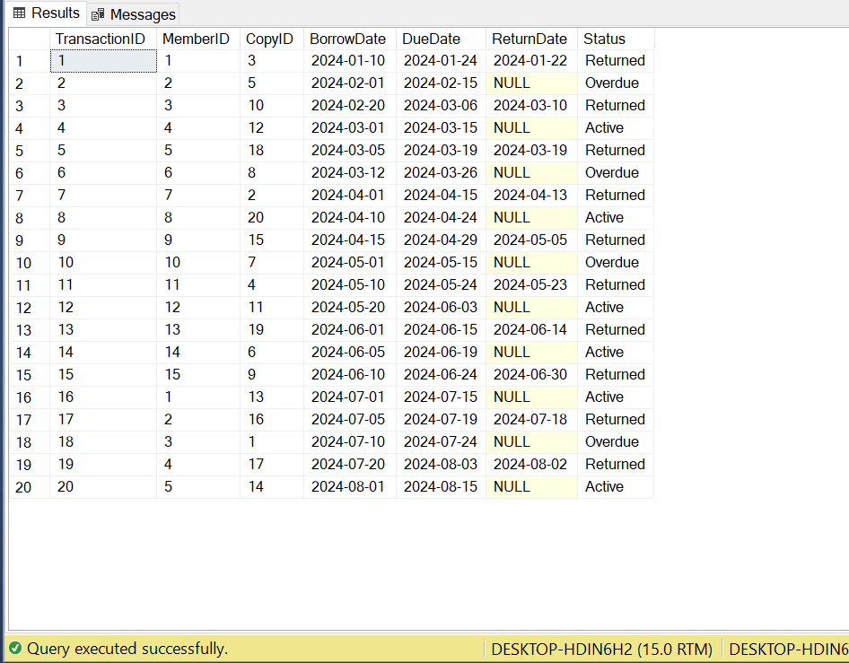
-- BorrowTransaction
INSERT INTO BorrowTransaction
(MemberID, CopyID, BorrowDate, DueDate, ReturnDate, Status) VALUES
(1, 3, '2024-01-10','2024-01-24','2024-01-22','Returned'),
(2, 5, '2024-02-01','2024-02-15',NULL, 'Overdue'),
(3, 10, '2024-02-20','2024-03-06','2024-03-10','Returned'),
(4, 12, '2024-03-01','2024-03-15',NULL, 'Active'),
(5, 18, '2024-03-05','2024-03-19','2024-03-19','Returned'),
(6, 8, '2024-03-12','2024-03-26',NULL, 'Overdue'),
(7, 2, '2024-04-01','2024-04-15','2024-04-13','Returned'),
(8, 20, '2024-04-10','2024-04-24',NULL, 'Active'),
(9, 15, '2024-04-15','2024-04-29','2024-05-05','Returned'),
(10, 7, '2024-05-01','2024-05-15',NULL, 'Overdue'),
(11, 4, '2024-05-10','2024-05-24','2024-05-23','Returned'),
(12, 11, '2024-05-20','2024-06-03',NULL, 'Active'),
(13, 19, '2024-06-01','2024-06-15','2024-06-14','Returned'),
(14, 6, '2024-06-05','2024-06-19',NULL, 'Active'),
(15, 9, '2024-06-10','2024-06-24','2024-06-30','Returned'),
(1, 13, '2024-07-01','2024-07-15',NULL, 'Active'),
(2, 16, '2024-07-05','2024-07-19','2024-07-18','Returned'),
(3, 1, '2024-07-10','2024-07-24',NULL, 'Overdue'),
(4, 17, '2024-07-20','2024-08-03','2024-08-02','Returned'),
(5, 14, '2024-08-01','2024-08-15',NULL, 'Active');

20 borrow transactions are inserted spanning January to August 2024. Status values: Returned (9 transactions), Active (6 transactions - not yet due), and Overdue (5 transactions - past due with no return date). ReturnDate is NULL for Active and Overdue transactions.

Fine Data
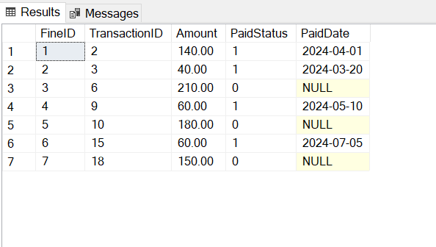
-- Fine
INSERT INTO Fine (TransactionID, Amount, PaidStatus, PaidDate) VALUES
(2, 140.00, TRUE, '2024-04-01'),
(3, 40.00, TRUE, '2024-03-20'),
(6, 210.00, FALSE, NULL),
(9, 60.00, TRUE, '2024-05-10'),
(10, 180.00, FALSE, NULL),
(15, 60.00, TRUE, '2024-07-05'),
(18, 150.00, FALSE, NULL);

7 fine records are inserted. Fine amounts are calculated at Rs. 10 per overdue day. 4 fines have been paid (PaidStatus = TRUE with PaidDate recorded) and 3 remain unpaid (PaidStatus = FALSE, PaidDate = NULL). The largest unpaid fine is Rs. 210 (TransactionID 6).

Reservation Data
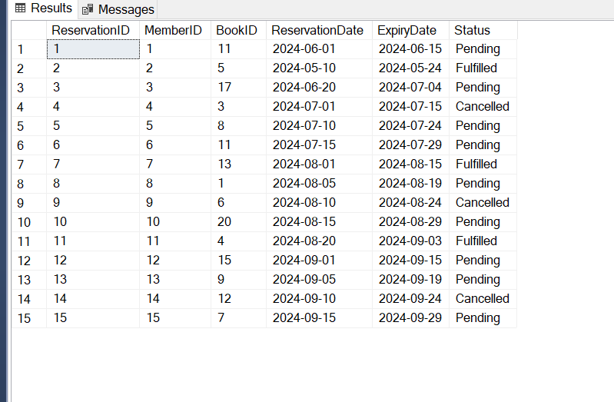
-- Reservation
INSERT INTO Reservation
(MemberID, BookID, ReservationDate, ExpiryDate, Status) VALUES
(1, 11, '2024-06-01','2024-06-15','Pending'),
(2, 5, '2024-05-10','2024-05-24','Fulfilled'),
(3, 17, '2024-06-20','2024-07-04','Pending'),
(4, 3, '2024-07-01','2024-07-15','Cancelled'),
(5, 8, '2024-07-10','2024-07-24','Pending'),
(6, 11, '2024-07-15','2024-07-29','Pending'),
(7, 13, '2024-08-01','2024-08-15','Fulfilled'),
(8, 1, '2024-08-05','2024-08-19','Pending'),
(9, 6, '2024-08-10','2024-08-24','Cancelled'),
(10, 20, '2024-08-15','2024-08-29','Pending'),
(11, 4, '2024-08-20','2024-09-03','Fulfilled'),
(12, 15, '2024-09-01','2024-09-15','Pending'),
(13, 9, '2024-09-05','2024-09-19','Pending'),
(14, 12, '2024-09-10','2024-09-24','Cancelled'),
(15, 7, '2024-09-15','2024-09-29','Pending');

15 reservations are inserted. Status distribution: Pending (9 reservations - still waiting), Fulfilled (3 reservations - book was provided), and Cancelled (3 reservations - member cancelled or book became unavailable). BookID 11 (Introduction to Algorithms) appears twice showing high demand.
code
-- ============================================================
-- Library Management System - Complete SQL Script
-- CS160 Database Systems | NUTECH
-- Run this file in SQL Server Management Studio (SSMS)
-- ============================================================

-- Create Database
IF NOT EXISTS (SELECT * FROM sys.databases WHERE name = 'LibraryDB')
BEGIN
CREATE DATABASE LibraryDB;
END
GO

USE LibraryDB;
GO

-- ============================================================
-- TASK 3: DDL - CREATE TABLE Scripts
-- ============================================================

-- Table: Category
CREATE TABLE Category (
CategoryID INT IDENTITY(1,1) PRIMARY KEY,
CategoryName VARCHAR(80) NOT NULL UNIQUE,
Description VARCHAR(255) NULL
);

-- Table: Book
CREATE TABLE Book (
BookID INT IDENTITY(1,1) PRIMARY KEY,
ISBN VARCHAR(20) NOT NULL UNIQUE,
Title VARCHAR(200) NOT NULL,
PublicationYear INT NOT NULL,
Publisher VARCHAR(100) NOT NULL,
CategoryID INT NOT NULL,
TotalCopies INT NOT NULL DEFAULT 0 CHECK (TotalCopies >= 0),
AvailableCopies INT NOT NULL DEFAULT 0 CHECK (AvailableCopies >= 0),
CONSTRAINT fk_book_category FOREIGN KEY (CategoryID)
REFERENCES Category(CategoryID) ON DELETE NO ACTION ON UPDATE CASCADE
);

-- Table: BookCopy (Weak Entity)
CREATE TABLE BookCopy (
CopyID INT IDENTITY(1,1) PRIMARY KEY,
BookID INT NOT NULL,
Condition VARCHAR(10) NOT NULL DEFAULT 'Good' CHECK (Condition IN ('Good','Fair','Damaged')),
IsAvailable BIT NOT NULL DEFAULT 1,
AcquiredDate DATE NOT NULL,
CONSTRAINT fk_copy_book FOREIGN KEY (BookID)
REFERENCES Book(BookID) ON DELETE CASCADE ON UPDATE CASCADE
);

-- Table: Author
CREATE TABLE Author (
AuthorID INT IDENTITY(1,1) PRIMARY KEY,
FirstName VARCHAR(50) NOT NULL,
LastName VARCHAR(50) NOT NULL,
Nationality VARCHAR(50) NULL,
BirthYear INT NULL
);

-- Table: BookAuthor (Associative - Many-to-Many)
CREATE TABLE BookAuthor (
BookID INT NOT NULL,
AuthorID INT NOT NULL,
PRIMARY KEY (BookID, AuthorID),
CONSTRAINT fk_ba_book FOREIGN KEY (BookID) REFERENCES Book(BookID) ON DELETE CASCADE,
CONSTRAINT fk_ba_author FOREIGN KEY (AuthorID) REFERENCES Author(AuthorID) ON DELETE CASCADE
);

-- Table: Member
CREATE TABLE Member (
MemberID INT IDENTITY(1,1) PRIMARY KEY,
CardNumber VARCHAR(20) NOT NULL UNIQUE,
FullName VARCHAR(100) NOT NULL,
Email VARCHAR(100) NOT NULL UNIQUE,
Street VARCHAR(100) NULL,
City VARCHAR(50) NULL,
ZipCode VARCHAR(10) NULL,
MembershipType VARCHAR(10) NOT NULL DEFAULT 'Standard' CHECK (MembershipType IN ('Standard','Premium')),
JoinDate DATE NOT NULL,
IsActive BIT NOT NULL DEFAULT 1
);

-- Table: MemberPhone (Multi-valued attribute)
CREATE TABLE MemberPhone (
PhoneID INT IDENTITY(1,1) PRIMARY KEY,
MemberID INT NOT NULL,
Phone VARCHAR(15) NOT NULL,
CONSTRAINT fk_phone_member FOREIGN KEY (MemberID)
REFERENCES Member(MemberID) ON DELETE CASCADE
);

-- Table: Staff (Supertype)
CREATE TABLE Staff (
StaffID INT IDENTITY(1,1) PRIMARY KEY,
FullName VARCHAR(100) NOT NULL,
Email VARCHAR(100) NOT NULL UNIQUE,
HireDate DATE NOT NULL,
Salary DECIMAL(10,2) NOT NULL CHECK (Salary > 0),
StaffType VARCHAR(15) NOT NULL CHECK (StaffType IN ('Librarian','Assistant','Admin'))
);

-- Table: Librarian (Subtype)
CREATE TABLE Librarian (
StaffID INT PRIMARY KEY,
Specialization VARCHAR(80) NULL,
CONSTRAINT fk_librarian_staff FOREIGN KEY (StaffID)
REFERENCES Staff(StaffID) ON DELETE CASCADE
);

-- Table: Assistant (Subtype)
CREATE TABLE Assistant (
StaffID INT PRIMARY KEY,
ShiftTime VARCHAR(10) NOT NULL CHECK (ShiftTime IN ('Morning','Evening','Night')),
CONSTRAINT fk_assistant_staff FOREIGN KEY (StaffID)
REFERENCES Staff(StaffID) ON DELETE CASCADE
);

-- Table: Admin (Subtype)
CREATE TABLE Admin (
StaffID INT PRIMARY KEY,
AccessLevel VARCHAR(10) NOT NULL DEFAULT 'Level1' CHECK (AccessLevel IN ('Level1','Level2','Level3')),
CONSTRAINT fk_admin_staff FOREIGN KEY (StaffID)
REFERENCES Staff(StaffID) ON DELETE CASCADE
);

-- Table: BorrowTransaction (Associative Entity)
CREATE TABLE BorrowTransaction (
TransactionID INT IDENTITY(1,1) PRIMARY KEY,
MemberID INT NOT NULL,
CopyID INT NOT NULL,
BorrowDate DATE NOT NULL,
DueDate DATE NOT NULL,
ReturnDate DATE NULL,
Status VARCHAR(10) NOT NULL DEFAULT 'Active' CHECK (Status IN ('Active','Returned','Overdue')),
CONSTRAINT fk_bt_member FOREIGN KEY (MemberID)
REFERENCES Member(MemberID) ON DELETE NO ACTION,
CONSTRAINT fk_bt_copy FOREIGN KEY (CopyID)
REFERENCES BookCopy(CopyID) ON DELETE NO ACTION,
CONSTRAINT chk_due CHECK (DueDate > BorrowDate)
);

-- Table: Fine
CREATE TABLE Fine (
FineID INT IDENTITY(1,1) PRIMARY KEY,
TransactionID INT NOT NULL UNIQUE,
Amount DECIMAL(8,2) NOT NULL CHECK (Amount >= 0),
PaidStatus BIT NOT NULL DEFAULT 0,
PaidDate DATE NULL,
CONSTRAINT fk_fine_transaction FOREIGN KEY (TransactionID)
REFERENCES BorrowTransaction(TransactionID) ON DELETE CASCADE
);

-- Table: Reservation
CREATE TABLE Reservation (
ReservationID INT IDENTITY(1,1) PRIMARY KEY,
MemberID INT NOT NULL,
BookID INT NOT NULL,
ReservationDate DATE NOT NULL,
ExpiryDate DATE NOT NULL,
Status VARCHAR(10) NOT NULL DEFAULT 'Pending' CHECK (Status IN ('Pending','Fulfilled','Cancelled')),
CONSTRAINT fk_res_member FOREIGN KEY (MemberID)
REFERENCES Member(MemberID) ON DELETE CASCADE,
CONSTRAINT fk_res_book FOREIGN KEY (BookID)
REFERENCES Book(BookID) ON DELETE CASCADE,
CONSTRAINT chk_expiry CHECK (ExpiryDate > ReservationDate)
);
GO

-- ============================================================
-- TASK 4: DML - INSERT Data
-- ============================================================

-- Category (10 rows)
INSERT INTO Category (CategoryName, Description) VALUES
('Fiction', 'Novels, short stories, and imaginative narratives'),
('Non-Fiction', 'Factual books based on real events or topics'),
('Science', 'Physics, Biology, Chemistry, and related fields'),
('Technology', 'Computing, networking, AI, and software engineering'),
('History', 'Historical accounts and biographies'),
('Mathematics', 'Pure and applied mathematics'),
('Literature', 'Classic and modern literary works'),
('Self-Help', 'Personal development and motivational books'),
('Business', 'Entrepreneurship, management, and economics'),
('Philosophy', 'Philosophical thought and ethics');

-- Book (20 rows)
INSERT INTO Book (ISBN, Title, PublicationYear, Publisher, CategoryID, TotalCopies, AvailableCopies) VALUES
('978-0061965784', 'Brave New World', 1932, 'Harper Perennial', 1, 5, 3),
('978-0743273565', 'The Great Gatsby', 1925, 'Scribner', 7, 4, 2),
('978-0307474278', 'The Da Vinci Code', 2003, 'Anchor Books', 1, 6, 4),
('978-0201616224', 'The Pragmatic Programmer', 1999, 'Addison-Wesley', 4, 3, 1),
('978-0132350884', 'Clean Code', 2008, 'Prentice Hall', 4, 4, 2),
('978-0385737951', 'The Hunger Games', 2008, 'Scholastic', 1, 7, 5),
('978-0393356250', 'Sapiens', 2011, 'Harper Collins', 5, 5, 3),
('978-0674034624', 'The Elements of Statistical Learning', 2001, 'Springer', 3, 2, 1),
('978-0062316097', 'The Alchemist', 1988, 'HarperOne', 8, 6, 4),
('978-1501156700', 'It Ends with Us', 2016, 'Atria Books', 1, 5, 3),
('978-0521880688', 'Introduction to Algorithms', 2009, 'MIT Press', 6, 3, 0),
('978-0316769174', 'The Catcher in the Rye', 1951, 'Little Brown', 7, 4, 2),
('978-0393351590', 'Thinking Fast and Slow', 2011, 'Farrar Straus', 8, 4, 3),
('978-1501175466', 'Educated', 2018, 'Random House', 2, 5, 4),
('978-0062641540', 'Shoe Dog', 2016, 'Scribner', 9, 3, 2),
('978-0374533557', 'Meditations', 1900, 'Farrar Straus', 10, 4, 3),
('978-0385490818', '1984', 1949, 'Secker Warburg', 1, 6, 2),
('978-0198526636', 'A Brief History of Time', 1988, 'Bantam Books', 3, 5, 3),
('978-0735224292', 'Little Fires Everywhere', 2017, 'Penguin Press', 1, 4, 2),
('978-0735211292', 'The Silent Patient', 2019, 'Celadon Books', 1, 5, 3);

-- Author (20 rows)
INSERT INTO Author (FirstName, LastName, Nationality, BirthYear) VALUES
('Aldous', 'Huxley', 'British', 1894),
('F. Scott', 'Fitzgerald', 'American', 1896),
('Dan', 'Brown', 'American', 1964),
('Andrew', 'Hunt', 'American', 1964),
('Robert', 'Martin', 'American', 1952),
('Suzanne', 'Collins', 'American', 1962),
('Yuval', 'Harari', 'Israeli', 1976),
('Paulo', 'Coelho', 'Brazilian', 1947),
('Colleen', 'Hoover', 'American', 1979),
('Thomas', 'Cormen', 'American', 1956),
('J.D.', 'Salinger', 'American', 1919),
('Daniel', 'Kahneman', 'Israeli', 1934),
('Tara', 'Westover', 'American', 1986),
('Phil', 'Knight', 'American', 1938),
('Marcus', 'Aurelius', 'Roman', 1901),
('George', 'Orwell', 'British', 1903),
('Stephen', 'Hawking', 'British', 1942),
('Celeste', 'Ng', 'American', 1980),
('Alex', 'Michaelides', 'British', 1977),
('Hasib', 'Leiserson', 'American', 1960);

-- BookAuthor (21 rows)
INSERT INTO BookAuthor (BookID, AuthorID) VALUES
(1,1),(2,2),(3,3),(4,4),(5,5),(6,6),(7,7),
(8,10),(8,20),
(9,8),(10,9),(11,10),(12,11),(13,12),(14,13),
(15,14),(16,15),(17,16),(18,17),(19,18),(20,19);

-- BookCopy (20 rows) - True mapping to 1, False mapping to 0
INSERT INTO BookCopy (BookID, Condition, IsAvailable, AcquiredDate) VALUES
(1, 'Good', 1, '2021-03-10'),
(1, 'Good', 1, '2021-03-10'),
(1, 'Fair', 0, '2020-01-15'),
(2, 'Good', 1, '2020-06-20'),
(2, 'Fair', 0, '2021-07-01'),
(3, 'Good', 1, '2022-01-05'),
(3, 'Good', 1, '2022-01-05'),
(3, 'Good', 0, '2022-01-05'),
(4, 'Good', 1, '2019-11-11'),
(4, 'Damaged', 0, '2018-08-08'),
(5, 'Good', 1, '2020-05-01'),
(5, 'Fair', 0, '2020-05-01'),
(6, 'Good', 1, '2021-09-15'),
(6, 'Good', 1, '2021-09-15'),
(6, 'Good', 0, '2021-09-15'),
(7, 'Good', 1, '2022-03-20'),
(7, 'Good', 0, '2022-03-20'),
(11, 'Good', 0, '2020-12-25'),
(17, 'Good', 1, '2019-06-01'),
(17, 'Fair', 0, '2019-06-01');

-- Member (15 rows) - True mapping to 1, False mapping to 0
INSERT INTO Member (CardNumber, FullName, Email, Street, City, ZipCode, MembershipType, JoinDate, IsActive) VALUES
('LIB-001', 'Ahmed Khan', 'ahmed.khan@gmail.com', 'Street 5', 'Islamabad', '44000', 'Premium', '2022-01-10', 1),
('LIB-002', 'Sara Ali', 'sara.ali@yahoo.com', 'Block B', 'Rawalpindi', '46000', 'Standard', '2022-03-15', 1),
('LIB-003', 'Bilal Nawaz', 'bilal.nawaz@hotmail.com', 'Sector G-9', 'Islamabad', '44090', 'Standard', '2021-07-20', 1),
('LIB-004', 'Fatima Malik', 'fatima.m@gmail.com', 'Model Town', 'Lahore', '54000', 'Premium', '2023-02-01', 1),
('LIB-005', 'Usman Raza', 'usman.raza@gmail.com', 'DHA Phase 2', 'Karachi', '75500', 'Standard', '2020-11-05', 1),
('LIB-006', 'Zara Hussain', 'zara.h@outlook.com', 'F-7 Markaz', 'Islamabad', '44000', 'Premium', '2022-05-22', 1),
('LIB-007', 'Hamid Sheikh', 'hamid.sh@gmail.com', 'Gulshan-e-Iqbal', 'Karachi', '75300', 'Standard', '2023-06-10', 1),
('LIB-008', 'Nadia Qureshi', 'nadia.q@gmail.com', 'Johar Town', 'Lahore', '54600', 'Standard', '2021-12-01', 0),
('LIB-009', 'Tariq Jamil', 'tariq.jamil@yahoo.com', 'Clifton', 'Karachi', '75600', 'Premium', '2020-08-14', 1),
('LIB-010', 'Ayesha Siddiqui', 'ayesha.s@gmail.com', 'I-8', 'Islamabad', '44080', 'Standard', '2022-09-30', 1),
('LIB-011', 'Kamran Baig', 'kamran.b@gmail.com', 'Gulberg III', 'Lahore', '54660', 'Standard', '2023-01-17', 1),
('LIB-012', 'Hina Afzal', 'hina.a@hotmail.com', 'North Nazimabad', 'Karachi', '74700', 'Premium', '2021-04-25', 1),
('LIB-013', 'Omer Farooq', 'omer.f@gmail.com', 'G-10', 'Islamabad', '44100', 'Standard', '2020-06-06', 1),
('LIB-014', 'Sana Tariq', 'sana.t@yahoo.com', 'Township', 'Lahore', '54800', 'Standard', '2022-11-11', 1),
('LIB-015', 'Asad Mehmood', 'asad.m@gmail.com', 'Malir', 'Karachi', '75080', 'Premium', '2023-03-28', 1);

-- MemberPhone (17 rows)
INSERT INTO MemberPhone (MemberID, Phone) VALUES
(1, '0300-1234567'), (1, '0321-9876543'),
(2, '0333-1112222'), (3, '0311-3334444'),
(4, '0345-5556666'), (4, '0321-7778888'),
(5, '0301-9990000'), (6, '0322-1231231'),
(7, '0312-4564564'), (8, '0315-7897897'),
(9, '0346-1010101'), (10, '0303-2020202'),
(11, '0344-3030303'), (12, '0308-4040404'),
(13, '0319-5050505'), (14, '0329-6060606'),
(15, '0302-7070707');

-- Staff (10 rows)
INSERT INTO Staff (FullName, Email, HireDate, Salary, StaffType) VALUES
('Dr. Imran Shah', 'imran.shah@library.edu.pk', '2018-01-15', 75000.00, 'Librarian'),
('Ms. Rabia Noor', 'rabia.noor@library.edu.pk', '2019-06-01', 45000.00, 'Assistant'),
('Mr. Faisal Khan', 'faisal.k@library.edu.pk', '2020-03-10', 80000.00, 'Admin'),
('Mrs. Amna Riaz', 'amna.r@library.edu.pk', '2021-08-20', 70000.00, 'Librarian'),
('Mr. Rizwan Butt', 'rizwan.b@library.edu.pk', '2022-02-14', 42000.00, 'Assistant'),
('Ms. Sobia Akhtar', 'sobia.a@library.edu.pk', '2017-11-30', 48000.00, 'Assistant'),
('Mr. Asif Raza', 'asif.r@library.edu.pk', '2016-05-05', 90000.00, 'Admin'),
('Dr. Nadia Islam', 'nadia.i@library.edu.pk', '2023-01-10', 68000.00, 'Librarian'),
('Mr. Junaid Ali', 'junaid.a@library.edu.pk', '2022-09-25', 44000.00, 'Assistant'),
('Ms. Bushra Khan', 'bushra.k@library.edu.pk', '2015-03-20', 95000.00, 'Admin');

INSERT INTO Librarian (StaffID, Specialization) VALUES
(1, 'Digital Resources'), (4, 'Archiving'), (8, 'Cataloguing');

INSERT INTO Assistant (StaffID, ShiftTime) VALUES
(2, 'Morning'), (5, 'Evening'), (6, 'Night'), (9, 'Morning');

INSERT INTO Admin (StaffID, AccessLevel) VALUES
(3, 'Level3'), (7, 'Level3'), (10, 'Level2');

-- BorrowTransaction (20 rows)
INSERT INTO BorrowTransaction (MemberID, CopyID, BorrowDate, DueDate, ReturnDate, Status) VALUES
(1, 3, '2024-01-10', '2024-01-24', '2024-01-22', 'Returned'),
(2, 5, '2024-02-01', '2024-02-15', NULL, 'Overdue'),
(3, 10, '2024-02-20', '2024-03-06', '2024-03-10', 'Returned'),
(4, 12, '2024-03-01', '2024-03-15', NULL, 'Active'),
(5, 18, '2024-03-05', '2024-03-19', '2024-03-19', 'Returned'),
(6, 8, '2024-03-12', '2024-03-26', NULL, 'Overdue'),
(7, 2, '2024-04-01', '2024-04-15', '2024-04-13', 'Returned'),
(8, 20, '2024-04-10', '2024-04-24', NULL, 'Active'),
(9, 15, '2024-04-15', '2024-04-29', '2024-05-05', 'Returned'),
(10, 7, '2024-05-01', '2024-05-15', NULL, 'Overdue'),
(11, 4, '2024-05-10', '2024-05-24', '2024-05-23', 'Returned'),
(12, 11, '2024-05-20', '2024-06-03', NULL, 'Active'),
(13, 19, '2024-06-01', '2024-06-15', '2024-06-14', 'Returned'),
(14, 6, '2024-06-05', '2024-06-19', NULL, 'Active'),
(15, 9, '2024-06-10', '2024-06-24', '2024-06-30', 'Returned'),
(1, 13, '2024-07-01', '2024-07-15', NULL, 'Active'),
(2, 16, '2024-07-05', '2024-07-19', '2024-07-18', 'Returned'),
(3, 1, '2024-07-10', '2024-07-24', NULL, 'Overdue'),
(4, 17, '2024-07-20', '2024-08-03', '2024-08-02', 'Returned'),
(5, 14, '2024-08-01', '2024-08-15', NULL, 'Active');

-- Fine (7 rows) - True mapping to 1, False mapping to 0
INSERT INTO Fine (TransactionID, Amount, PaidStatus, PaidDate) VALUES
(2, 140.00, 1, '2024-04-01'),
(3, 40.00, 1, '2024-03-20'),
(6, 210.00, 0, NULL),
(9, 60.00, 1, '2024-05-10'),
(10, 180.00, 0, NULL),
(15, 60.00, 1, '2024-07-05'),
(18, 150.00, 0, NULL);

-- Reservation (15 rows)
INSERT INTO Reservation (MemberID, BookID, ReservationDate, ExpiryDate, Status) VALUES
(1, 11, '2024-06-01', '2024-06-15', 'Pending'),
(2, 5, '2024-05-10', '2024-05-24', 'Fulfilled'),
(3, 17, '2024-06-20', '2024-07-04', 'Pending'),
(4, 3, '2024-07-01', '2024-07-15', 'Cancelled'),
(5, 8, '2024-07-10', '2024-07-24', 'Pending'),
(6, 11, '2024-07-15', '2024-07-29', 'Pending'),
(7, 13, '2024-08-01', '2024-08-15', 'Fulfilled'),
(8, 1, '2024-08-05', '2024-08-19', 'Pending'),
(9, 6, '2024-08-10', '2024-08-24', 'Cancelled'),
(10, 20, '2024-08-15', '2024-08-29', 'Pending'),
(11, 4, '2024-08-20', '2024-09-03', 'Fulfilled'),
(12, 15, '2024-09-01', '2024-09-15', 'Pending'),
(13, 9, '2024-09-05', '2024-09-19', 'Pending'),
(14, 12, '2024-09-10', '2024-09-24', 'Cancelled'),
(15, 7, '2024-09-15', '2024-09-29', 'Pending');
GO

-- ============================================================
-- Done. All tables created and populated for SQL Server.
-- ============================================================

USE LibraryDB;
GO

-- ============================================================
-- GROUP 1: BOOK CATALOG & INVENTORY TABLES
-- ============================================================

PRINT '==================== 1. CATEGORIES ====================';
SELECT * FROM Category;

PRINT '==================== 2. BOOKS ====================';
SELECT * FROM Book;

PRINT '==================== 3. AUTHORS ====================';
SELECT * FROM Author;

PRINT '==================== 4. BOOK-AUTHOR MAPPINGS ====================';
SELECT * FROM BookAuthor;

PRINT '==================== 5. PHYSICAL BOOK COPIES ====================';
SELECT * FROM BookCopy;

-- ============================================================
-- GROUP 2: MEMBERSHIP TABLES
-- ============================================================

PRINT '==================== 6. MEMBERS ====================';
SELECT * FROM Member;

PRINT '==================== 7. MEMBER PHONE NUMBERS ====================';
SELECT * FROM MemberPhone;

-- ============================================================
-- GROUP 3: STAFF HIERARCHY TABLES
-- ============================================================

PRINT '==================== 8. BASE STAFF RECORDS ====================';
SELECT * FROM Staff;

PRINT '==================== 9. LIBRARIANS (SUBTYPE) ====================';
SELECT * FROM Librarian;

PRINT '==================== 10. ASSISTANTS (SUBTYPE) ====================';
SELECT * FROM Assistant;

PRINT '==================== 11. ADMINS (SUBTYPE) ====================';
SELECT * FROM Admin;

-- ============================================================
-- GROUP 4: TRANSACTION & FINANCIAL TABLES
-- ============================================================

PRINT '==================== 12. BORROW TRANSACTIONS ====================';
SELECT * FROM BorrowTransaction;

PRINT '==================== 13. FINES ====================';
SELECT * FROM Fine;

PRINT '==================== 14. RESERVATIONS ====================';
SELECT * FROM Reservation;
GO

